

EASM.340 - Technical Installation for EHS - CONSOL1-757

CONSOL Energy Inc



Author: AST Corporation

File Name: EASM.340 - Technical Installation for EHS - CONSOL1-872

Version: 1.0

Release Date: Apr 10, 2019

Document Control

Modification Record

|  |  |  |  |
| --- | --- | --- | --- |
| Date | Author | Version | Change Reference |
| 04/10/19 | Romesh Soni | 1.0 | Document started with JCS Installation Instructions |
|  |  |  |  |

Reviewed By

|  |  |  |
| --- | --- | --- |
| Name | Title/Role | Date |
|  |  |  |
|  |  |  |
|  |  |  |

Distribution List

|  |  |  |
| --- | --- | --- |
| Name | Title/Role | Date |
| AST Managed Services |  |  |
|  |  |  |

Table of Contents

1. Introduction 4

1.1 JCS Application Installation Steps 4

1.1.1 Pre-requisite Steps – Backup existing application 4

1.1.2 Implementation Steps – Deploy the ear 7

1.1.3 Post installation - Verify 8

# Introduction

This document outlines the steps required to migrate the technical components for CONSOL1-872 ticket.

## JCS Application Installation Steps

JCS Application is attached to the ticket as “CEIX_OrderQualityLabResultsSearch.ear”. The below steps describe how to deploy this in JCS WebLogic.

### Pre-requisite Steps – Backup existing application

#### Backup existing ear Application

* Take a backup of existing application

Login to weblogic environment from ftp client – winscp being used here. Below details are provided for dev2 environment which is logged in using opc user:

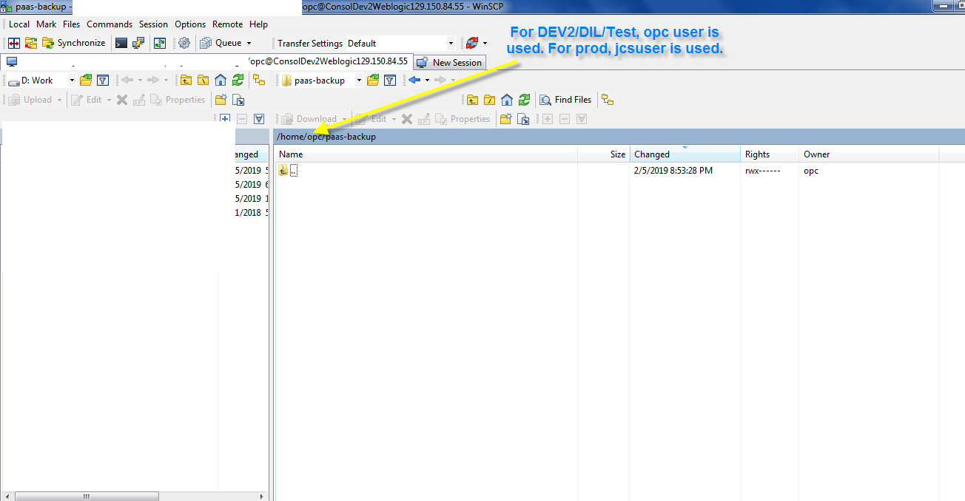

* Get inside the /home/opc/paas-backup directory. Note. For **test environment**, the user is opc (Note that for the **Prod environment**, the directory must be /home/jcsuser/paas-backup)
* Inside this folder (paas-backup), create a folder named CEIX_OrderQualityLabResultsSearch, if it doesn’t already exists. Skip this step if the folder already present.:

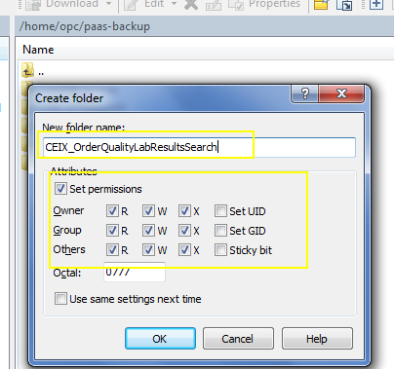

* Now you need to take backup of existing application inside “/home/opc/paas-backup/CEIX_OrderQualityLabResultsSearch” folder.
* Inside this “/home/opc/paas-backup/CEIX_OrderQualityLabResultsSearch” folder ,create a sub folder with name: ddmmyy_ CONSOL1-757. Replace the ddmmyy with the date when you are taking the backup.

e.g. below image is shown for dev2 environment:

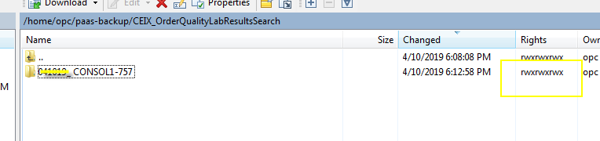

* Login to weblogic environment using putty
* Use the same user to login which you used for Putty (i.e. For Production jcsuser is used and for tst opc user is used.)
* Do sudo su

Below is example for opc user:

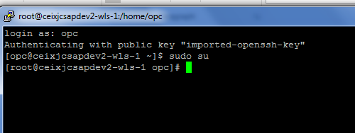

* The application deployed previously is stored in “/u01/data/domains/ceixjcsa_domain/servers/ceixjcsa_adminserver/upload” folder

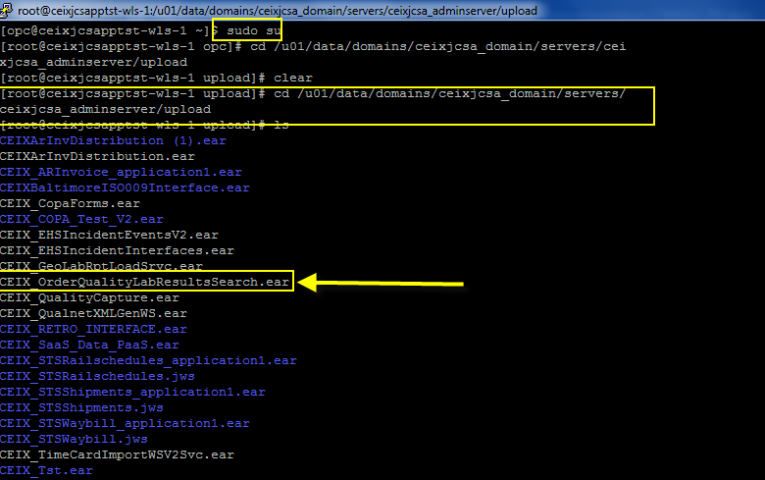

* To take backup of the CEIX_EHSIncidentEventsV2.ear, replace the highlighted part (ddMMyy) in below command with the date when you are running the command:

**FOR TEST:**

cp /u01/data/domains/ceixjcsa_domain/servers/ceixjcsa_adminserver/upload/CEIX_OrderQualityLabResultsSearch.ear /home/opc/paas-backup/CEIX_OrderQualityLabResultsSearch/ddMMyy_CONSOL1-757

**FOR PROD:**

cp /u01/data/domains/ceixjcsa_domain/servers/ceixjcsa_adminserver/upload/CEIX_OrderQualityLabResultsSearch.ear/app/CEIX_OrderQualityLabResultsSearch.ear /home/jcsuser/paas-backup/CEIX_OrderQualityLabResultsSearch/ddMMyy_CONSOL1-757

**Note: Unlike Test environment, in Production, the application is inside “/u01/data/domains/ceixjcsa_domain/servers/ceixjcsa_adminserver/upload/CEIX_OrderQualityLabResultsSearch.ear/app” directory.**

* This will copy the existing application to backup folder:

### Implementation Steps – Deploy the ear

#### Deploy the application

* Login to weblogic environment and do “Lock and Edit”
* Go to deployments
* Select CEIX_OrderQualityLabResultsSearch and click on Update

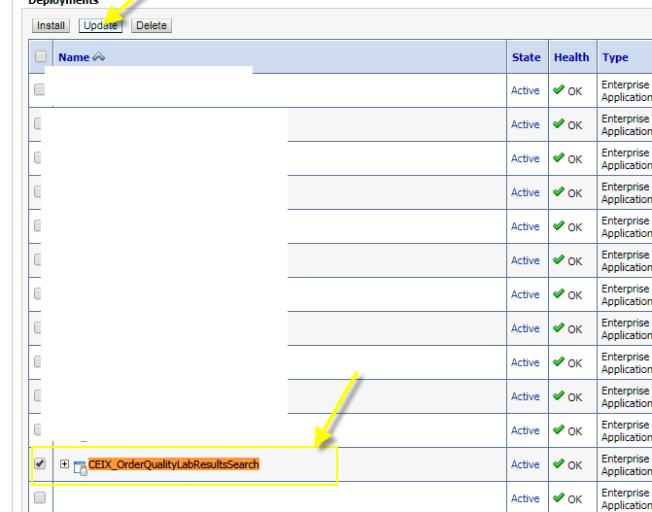

* In the next page click on Change Path:

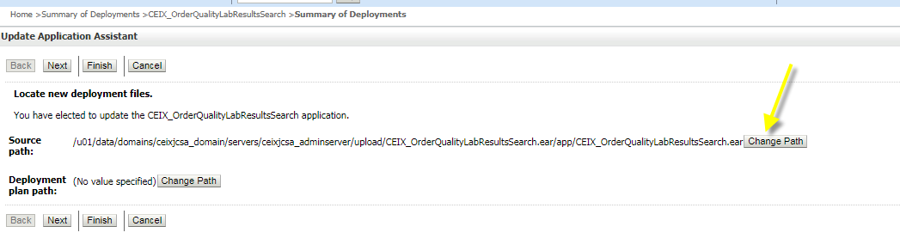

* In next screen, click “upload your file(s):

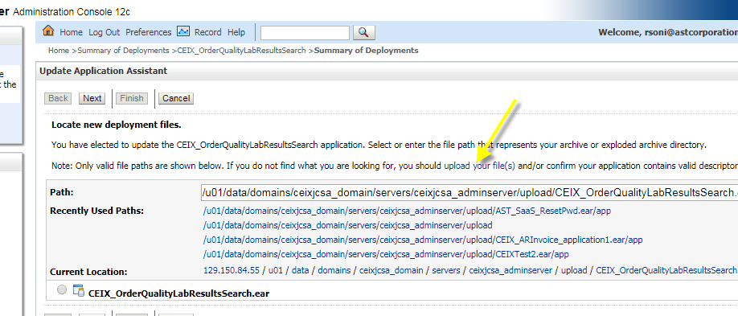

* In next screen, click “Choose File” button. This will open Browse popup.
* Select new CEIX_OrderQualityLabResultsSearch.ear file which is attached to the ticket.
* Click Next.
* This will start uploading the file.
* Once file is uploaded, click Next and then click Finish in the next page.
* At the end, click “Activate Changes” button.

### Post installation - Verify

#### Verify Application availability

* Make sure the application is available by browsing through the application from SaaS navigation.

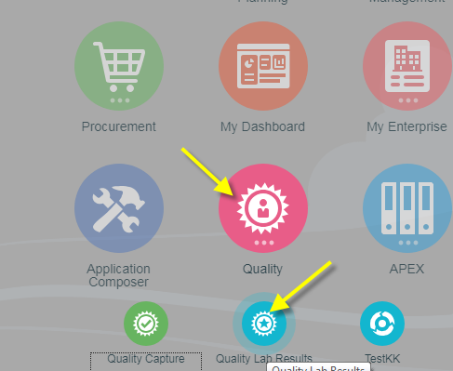

* Click ON Quality Lab Results link and below page must load:

